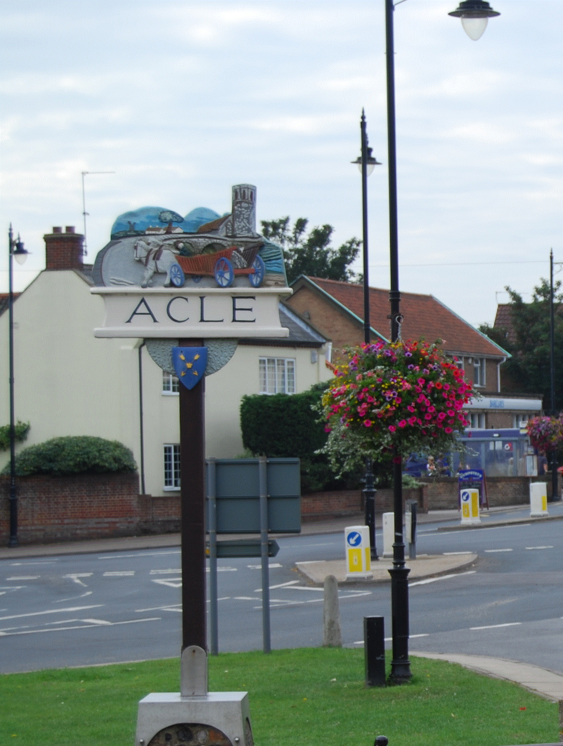

ACLE PARISH COUNCIL

Freedom of Information Model Publication Scheme

Approved and adopted by Acle Parish Council

Date of next review: 31st January 2022
Information available from Acle Parish Council under their publication scheme

Hard copies of documents are available from the Clerk and will be charged in accordance with the Schedule on Page 7.

Information to be published | How the information can be obtained | Cost
Class1 - Who we are and what we do  (Organisational information, structures, locations and contacts)  This will be current information only | From the Council’s website  Displayed on noticeboards  As a hard copy from the Clerk/Deputy, or electronically attached to an email from the Clerk/Deputy | See costs on Page 8 for hard copies of documents in Class 1
Who’s who on the Council and its Committees | From the Council’s website  Displayed on noticeboards  As a hard copy from the Clerk/Deputy, or electronically attached to an e mail from the Clerk/Deputy | as above
Contact details for Parish Clerk and Councillors (named contacts where possible with telephone number and email address, if used) | From the Council’s website  Displayed on noticeboards  Clerk’s/Deputy’s contact details are on Page 7. Clerk/Deputy and Councillors’ details hard copy, as an attachment to an email from the Clerk/Deputy | as above
Location of main Council office and accessibility details | Office is in Clerk’s/Deputy’s home. Meetings at the Methodist Church, meetings open to public. Parking adjacent to the Hall
Staffing structure | Parish Clerk and RFO  Deputy Clerk and Asset Manager  Cleaner  Bank Cleaner
Class 2 – What we spend and how we spend it  (Financial information relating to projected and actual income and expenditure, procurement, contracts and financial audit)  Current and previous financial year as a minimum | From the Council’s website or as a  hard copy from the Clerk | See costs on Page 8 for hard copies of documents in Class 2
Annual Return (Pages 2, 3 and 5)  Reasons for Variations = / - 15%  Payments over £100 [if a council with turnover £25,000 or under] or payments over £500 [if a council with turnover £200,000 or over] | As above  As above  As above
Finalised budget | As above
Precept | From the Council’s website or as a  hard copy from the Clerk
Borrowing Approval letter | N/A
Financial Regulations and Standing Orders | From the Council’s website or as a  hard copy from the Clerk
Grants given and received  Grant Award Policy | From the Council’s website or as a  hard copy from the Clerk
List of current contracts awarded and value of contract  Street Lights Maintenance | Hard copy from the Clerk
Councillors’ allowances and expenses | N/A
Class 3 – What our priorities are and how we are doing  (Strategies and plans, performance indicators, audits, inspections and reviews) |  | See costs on Page 8 for hard copies of documents in Class 3
Action Plan/s  [if any] | From the Council’s website or as a  hard copy from the Clerk/Deputy
Chairman’s Annual Report to Parish Meeting (current year only) | From the Council’s website or as a  hard copy from the Clerk/Deputy
Minute relating to General Power of Competence adoption | Email or hard copy from the Clerk/Deputy
Class 4 – How we make decisions  (Decision making processes and records of decisions)  Current and previous council year as a minimum |  | See costs on Page 8 for hard copies of documents in Class 4
Timetable of meetings (Council, any committee/sub-committee meetings and parish meetings) | From the Council’s website or a  hard copy from the Clerk/Deputy  Parish noticeboard/s
Agendas of meetings (as above) | From the Council’s website or a  hard copy from the Clerk/Deputy
Minutes of meetings (as above) – NB this will exclude information that is properly regarded as private to the meeting | From the Council’s website or  hard copy from the Clerk/Deputy
Reports presented to council meetings - note this will exclude information that is properly regarded as private to the meeting | From the Council’s website or as a hard copy from the Clerk/Deputy
Responses to planning applications  Responses to consultation papers | See Minutes  From the Council’s website  Hard copy from the Clerk/Deputy
Class 5 – Our policies and procedures  (Current written protocols, policies and procedures for delivering services and responsibilities)  Current information only |  | See costs on Page 8 for hard copies of documents in Class 5
Policies – Planning Policy (how the Council deals with planning applications at parish council level), Code of Conduct and Dispensation Policy, Risk Management Policy | From the Council’s website or as a  hard copy from the Clerk/Deputy
Policies and procedures for the provision of services and about the employment of staff:  Equality and diversity policy  Lone Workers Policy  Training and Development Policy  Policies and procedures for handling requests for information  Freedom of Information Publication Scheme | From the Council’s website or as a  hard copy from the Clerk/Deputy
Complaints procedures (including those covering requests for information and operating the publication scheme) | From the Council’s website or as a  hard copy from the Clerk/Deputy
Class 6 – Lists and Registers  Currently maintained lists and registers only |  | See costs on Page 8 for hard copies of documents in Class 6
Any publicly available register or list (if any are held this should be publicised; in most circumstances existing access provisions will suffice) | N/A
Assets Register | From the Council’s website or as a  hard copy from the Clerk/Deputy
Register of members’/councillors’ interests | Available from Broadland District Council website
Register of gifts and hospitality | N/A
Class 7 – The services we offer  Information about the services the Council offers, including leaflets, guidance and newsletters produced for the public and businesses  Current information only | From the Council’s website or as a  hard copy from the Clerk/Deputy | See costs on Page 8 for hard copies of documents in Class 7
Burial Grounds and Closed Churchyards | Apply to the clerk/deputy
Parks, playing fields and recreational facilities | From the Council’s website or as a hard copy from the Clerk/Deputy
Seating, litter bins, clocks, memorials and lighting | As a hard copy from the Clerk/Deputy
Bus Shelter | From the Council’s website or as a hard copy from the Clerk/Deputy
Markets | From the Council’s website or as a hard copy from the Clerk/Deputy
Public conveniences | No relevant information
Agency agreements | No relevant information
Class 8 - Other Services provided within the Parish |  | See costs on Page 8 for hard copies of documents in Class 8
Acle Lands Trust | From the Council’s website or as a hard copy from the Clerk/Deputy
Acle Food Bank | From the Council’s website or as a hard copy from the Clerk/Deputy
Acle Community Gym | From the Council’s website or as a hard copy from the Clerk/Deputy
Allotments | From the Acle Allotment Association website
Acle and District Voluntary Aid | From the Council’s website or as a hard copy from the Clerk/Deputy
Acle Recreation Centre | From the Council’s website or as a hard copy from the Clerk/Deputy
Acle Village Website | Via the Council’s website
Acle Community Speed Watch | From the Council’s website or as a hard copy from the Clerk/Deputy
Acle Good Neighbour Scheme | From the Council’s website or as a hard copy from the Clerk/Deputy
Acle Heating Oil Buying Scheme | From the Council’s website or as a hard copy from the Clerk/Deputy
Acles Businesses List | From the Council’s website or as a hard copy from the Clerk/Deputy
Beeline for Acle | From the Council’s website or as a hard copy from the Clerk/Deputy
Acle Youth Club | From the Council’s website or as a hard copy from the Clerk/Deputy
Acle Men’s Shed | From the Council’s website or as a hard copy from the Clerk/Deputy
Acle Tree Warden | From the Council’s website or as a hard copy from the Clerk/Deputy

Contact details of the Clerk
Mrs Pauline James
Beech Farm
Marsh Road
Upton
NR13 6BP
aclepcclerk@gmail.com
01493 751070

Contact details of the Deputy Clerk
Mrs Becky Furr
2 Hall Cottages
The Windle
Acle
NR13 3JT
aclepcdeputyclerk@gmail.com
07536456161

Schedule of charges

This describes how the charges have been arrived at and should be published as part of the guide. (Below is an example of possible charges).

Type of charge | Description | Basis of charge
Disbursement cost | Photocopying @ 20p per single-sided sheet (black & white) | Actual cost based on computer printing
 | Photocopying @ £1.00p per single-sided sheet (colour) | Actual cost based on computer printing
 | Website | Free
 | Postage | Actual cost of Royal Mail standard 2nd class. Recorded delivery if requested at standard price

